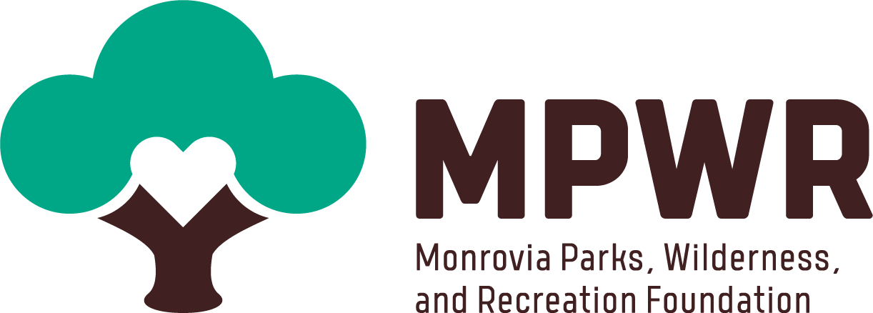
Become a Sponsor of the
Monrovia Parks, Wilderness, and Recreation Foundation

OUR MISSION IS TO SUPPORT RECREATION AND COMMUNITY PROGRAMS, PARKS, FACILITIES AND OPEN SPACES IN MONROVIA

Why support Monrovia parks and open space?

Our Parks, Open Spaces, and Trails provide numerous benefits to our community. Now, more than ever, we realize the importance of spending time outside and in nature to help clear our minds, renew our souls, exercise, or spend time with family and friends.
We all miss access to Canyon Park, but we have an opportunity to rise from the ashes by supporting our essential parks and open spaces in Monrovia and ensuring we have the resources, facilities and programs for the community to come back even stronger from the fire, flood and the pandemic.

Studies have shown that:
- Physical activity outside makes people healthier.
- Physical activity increases with access to parks.
- Contact with the natural world improves physical and mental health.
- Parks and Open spaces add value to the community and economic development.
- Trees are effective in improving air quality and assisting with stormwater control.
Your Support today can go a long way for our community.
Your Impact
Every sponsorship dollar makes a huge difference for more than 36,000 Monrovia residents and thousands of visitors each year. Your support makes it possible for us to provide youth sports scholarships, shade structures at urban park playgrounds, interpretive signage in all parks, the restoration of Canyon Park and much more.
Your donation today will help fund many kinds of projects, including:
- Scholarship for Youth Sports and Recreation Programs
$1,250 will offer the opportunity for ten local youth to participate in City sports and recreation programming.
- Shade structure
$70,000-$150,000 pays for one playground shade structure.
- Educational Signage
$2,500-$5,000 can help pay for a sign to share knowledge with the next generation.

Sponsorship Benefits and Opportunities
There are many ways your business can support our work:
- Providing a tax-deductible donation to support our programs and services
- Sponsoring one of our specific programs, including Youth Scholarships for sports, restoration of Canyon Park, Signage in Canyon Park and shade structures in urban parks
- Collaborating on a cause-marketing campaign
MPWR presents several opportunities throughout the year, many of which allow for maximized exposure to companies and families in our community. This is an amazing opportunity for you to establish your brand as a Partner in supporting our mission at certain levels of support:
- Logo or name on MPWR web site and newsletter.
- Logo or name included in a series of communications to MPWR members
- Recognition in social media posts and press releases
- Recognition at MPWR events

Sponsorship Giving Levels

Oak - $5,000
Our most generous sponsors who spread their branches far and wide.
- Presenting Sponsor Acknowledgement at Fall event
- Acknowledgment on signage for chosen program
- Signage at events
- Special placement on MPWR website
- 2 Social Media posts
- Multiple mentions during all events
- Table opportunity at event
Sycamore - $2,500
A sponsorship level that taps into our souls.
- Signage at events
- Logo on MPWR website
- 2 social media posts
- 1 mention during events
Cottonwood - $1,000
The level that helps us thrive and allows us to continue to share the love.
- Name recognition on a joint signage at events
- 2 Social media posts
- 1 mention at event
- Logo on MPWR website
Willow - $500
A level that provides flexibility for our programs and needs.
- Name recognition on a joint signage at events
- Logo listing on website
- 1 social media post
- 1 mention at an event
Manzanita - $250
A level that provides seeds for our growth.
- Logo listing on website
- 1 Social media post
Giving Tree Circle -$120
- 1 Social media post

Sponsorship Interest Form
Thank you for your interest in joining MPWR as a sponsor! Please complete the form below so that we can contact you regarding your participation. Alternatively, please contact (add a name, email, and phone number) to learn more about sponsor and vendor opportunities and their corresponding benefits.

Name
Name of Company
Company address
Phone number
Email
Company website

Briefly describe your business/organization:

Briefly describe the items and/or services you plan to display or sell:

Check which sponsorship level you are interested in:

- Oak
- Sycamore
- Cottonwood
- Willow
- Manzanita
- Giving Tree Circle
- Canyon Park Sponsor
- Youth Sports Sponsor
- Shade Structure Sponsor
- In-kind item-for our Auction

For payment, please pay online (https://monroviapwr.org/sponsorship) OR
mail-in this form with check or credit card info to
119 W. Palm Ave., Monrovia, CA 91016

Payment Type:

- Check
- Credit Card

Credit Card Type:

- Visa
- Mastercard

Credit Card Number

CVC | Expiration Date

Supporting recreation and community programs, parks, facilities, and open spaces in Monrovia. We are a 501(c)3 exempt organization and your support is tax-deductible according to the law. EIN 95-4839197. Visit www.monroviapwr.org to learn more.

